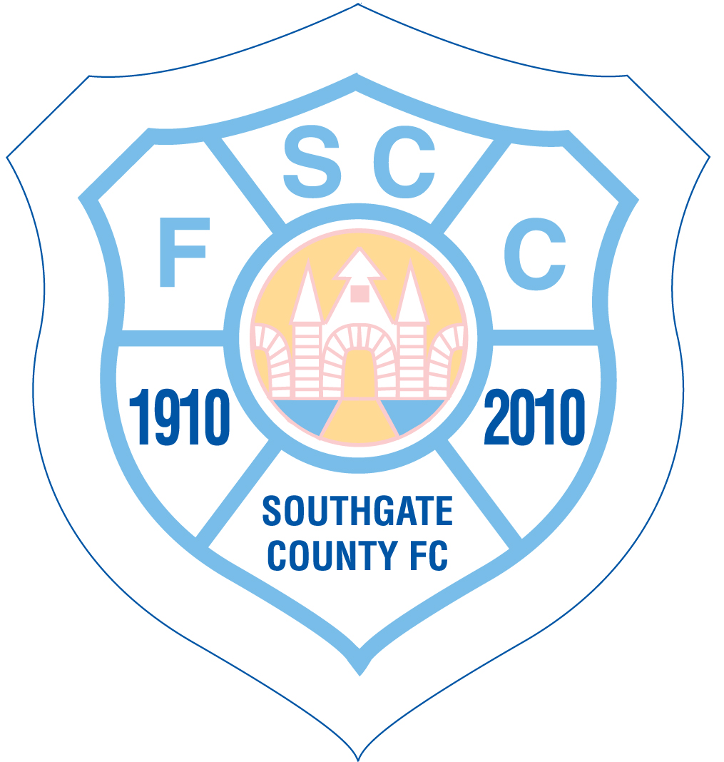

Spirit of Football Statement
Football is a game that owes much of its worldwide appeal to the fact that it should be played not only within its Laws but also within the SPIRIT OF THE GAME. Any action which is seen to abuse this spirit causes injury to the game itself. The MAJOR RESPONSIBILITY for ensuring the spirit of fair play on the field of play rests with the CAPTAINS AND MANAGERS.

RESPONSIBILITY OF CAPTAINS AND MANAGERS
Captains and Managers are responsible at all times for ensuring that their players conduct themselves within the Spirit of the Game as well as within the Laws.
FAIR AND UNFAIR PLAY
According to the Laws, the Referee is the SOLE JUDGE OF FAIR AND UNFAIR PLAY. Captains are expected to ensure that all decisions are accepted without dispute.
PLAYERS' CONDUCT
Any player who shows dissent by word or action, or behaves in an irresponsible manner which may bring the game into disrepute is liable to disciplinary action by the referee which should be supported by the captain and manager.
SPIRIT OF THE GAME
The Spirit of the Game involves showing RESPECT for:
Your opponents and their team officials
Your own captain and team
The role of the referee and assistant referees
Supporters and spectators OF ALL AGES
The Game's traditional values
It is AGAINST the Spirit of the Game
To protest against the referee's decisions by word or action
To use offensive, abusive or insulting language or gestures towards any person before, during or after a match, including spectators
To indulge in cheating, gamesmanship, time-wasting or any other unsporting behaviour
To advance towards, or react to, a referee in an aggressive manner
VIOLENCE
There is NO PLACE for any ACT OF VIOLENCE on the field of play.
PLAYERS
Captains, managers and officials together set the tone for the conduct of a football match.

EVERY PLAYER IS EXPECTED TO MAKE AN IMPORTANT CONTRIBUTION TOWARDS THIS
PLAY HARD, PLAY FAIR

